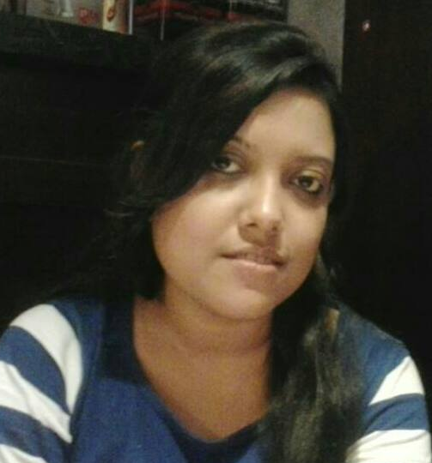
CURRICULUM VITAE

NAME: KATHAKOLI KANJILAL
MOBILE NO.: 8436395797, 9831623873
E-MAIL ID: kathakolikanjilal@gmail.com
OBJECTIVE: To build career in a growing organisation, where I can get the opportunities to prove my abilities by accepting challenges, fulfilling the organisational goal and climb the career ladder through continuous learning and commitment.
WORK EXPERIENCE:
iZodiaque Numerology Pvt Ltd (iZofy) from March 2016 till present
Designation: Account Manager
Job profile:
- Adding more Experts/Practitioners to the website - www.izofy.com
- Pitching about the services of the company to the Experts/Practitioners
- Maintaining relationship with the customers.
- Promptly replying to the queries of the customers on chat, email and phone
- Maintaining relationship with the vendors
- Handling social media pages like facebook, twitter and instagram
- Handling the BTL activities of the company

BlueAntz Creative Advertising, Kolkata from November 2014 till November 2015
Designation: Client Servicing Executive
Job profile:
- Interacting with the clients over phone and meetings.
- Briefing the creative team about client’s requirements which includes press ads, magazine ads, posters, OOH, customer brochures, E-mailers, website layout, visiting cards, leaflets, invitation cards, labels, stickers, user manuals, standee, backdrop, canopy, internal branding, mall branding etc.
- Writing creative briefs and giving insights about the creative.
- Giving ideas to the clients about various promotional strategies.
- Interacting with the vendors and presenting cost to the clients about various promotional activities.
- Preparing marketing strategies for a brand campaign.
- Market research projects on competitive brands.
- New Client acquisition

Brands:

- Philips
- Mars Plywood
- Adhunik TMT bars
- Sylvan Plywood
- Space Group
- N. K. Realtors

Magne Consulting Private Limited, Kolkata from December 2013 till August 2014
Designation: Consultant
Job Profile:
- Interaction with the clients, attending meetings, brand understanding.
- Briefing the creative team about client requirements.
- Conceptualizing and planning online marketing ads, events and social media campaigns for Facebook, Pinterest, LinkedIn and twitter and making relevant content.
- Attending promotional events and working on live tweeting
- Overseeing the delivery as well as working on social media research.

Brands:

  - Chandrani Pearls
  - Yoforia, India
  - Moustache Jeans
  - Titas Footwear
  - Blue&Blues
  - SanjhaChulha
  - City Centre
  - Massekah Fine Dining
  - The Sonnet Hotel
  - Wow!Momo
TRAINING:

P(x) Branding and Communication, Bangalore from May, 2013 to October, 2013.
Designation: Brand Custodian Trainee
Job profile:
- Briefing the creative team about client’s requirements which includes press ads, magazine ads, customer brochures, EDMs, websites, visiting cards, leaflets, fliers, invitations, labels, user manuals, standee, canopy, store branding, wall branding, van branding, lift branding, kiosk, signage etc.
- Giving ideas to the clients about various promotional strategies.
- Interacting with the vendors and presenting cost to the clients about various promotional activities.
- Giving product launch ideas to the client.
- Market research projects on competitive brands.

Brands:

- Fluke, India
- Toyota
- Own Water Purifier Pvt Ltd
- Sunspot [Paramount Cosmetics (I) Ltd]
- White lotus
- Featherlite

INTERNSHIPS:

1. Worked as an intern at Bates CHI & Partners, Kolkata from February 2013 to April 2013.
Job profile:
- Worked on projects like product proliferation of different brands in the market
- Written creative briefs on different brands
- Worked on different market research projects.
Brands:
- Centuryply
- P.C.Chandra Jewellers
- Desh Magazine
- UnishKuri Magazine
- Coke
- Safed detergent
- Dyna Roof
- Berger Paints
- Khadims footwear
- Heidelberg cement, Bangladesh
- Turtle

2. Worked as an intern at Percept/H Pvt Ltd, Bangalore from April 2012 to May 2012.
Job profile:
- Market research projects.
- Online and offline surveys and take vox-pops by visiting various malls in Bangalore.

Brands:
- Brand Factory
- Toyota
- Ascendas Park Square Mall, Bangalore

3. Worked as an intern at TWIN (Tollygunge Women In Need), Kolkata from October 2011 to November 2011

4. Worked as a part time investigator for the international passenger survey conducted by the Indian Statistical Institute, commissioned by the Ministry of Tourism and Civil Aviation from March 2010 to March 2011

QUALIFICATION:
- M.A.(Marketing and Management Communication) at Convergence Institute Of Media, Management and Information Studies, Bangalore, affiliated to Makhanlal Chaturvedi National University of Journalism & Communication, Bhopal (2011-2013)

- B.A. in Journalism and Mass Communication(Hons) from Muralidhar Girls’ College, Calcutta University (2008-2011)

- Class XII- Assembly of God Church School, Sodepur (Asansol), ISC (2008)

- Class X- Assembly of God Church School, Asansol, ICSE (2006)

PERSONAL INFORMATION:
PRESENT ADDRESS:
44/C, Pratap Aditya Road, Kolkata- 700026
PERMANENT ADDRESS:
‘UPASANA’,
POST: Searsole Rajbari , PIN: 713358, DIST: Burdwan
PS: Raniganj (West Bengal)
GENDER: Female
LANGUAGES: Bengali, English and Hindi

DECLARATION:
I solemnly declare that the all the above information is correct to the best of my knowledge and belief.

Signature

